**Sample Css Program**

<html>

<head>

<title>CSS styles</title>

<style type="text/css">

h1{

font-size: 16;

font-weight: bold;

font-family: arial;

color: red;

}

p.one{

color: red;

}

p.two{

color: green;

}

p.sample{

color: blue;

}

#id1{

color: yellow;

}

</style>

</head>

<body>

<h1>Introduction to CSS</h1>

<p class="one">CSS stands for Cascading style sheet</p>

<p class="two">CSS is used to various style specifications</p>

<p class="sample">Three levels of css are Inline,Extenal,Document</p>

<p style="color: black; font-size: 16">

Order of preference is inline folwed by document follwed by external</p>

<h3 id="id1">This is id style selector</h3>

</body>

</html>

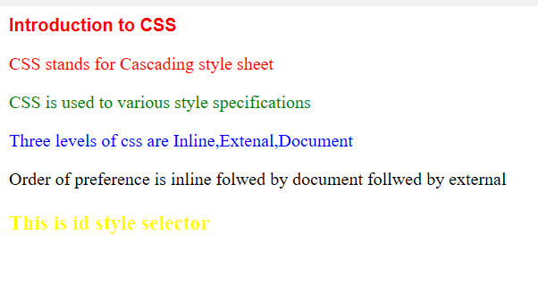

**Lists in CSS**

<html>

<head>

<style type="text/css">

ul.class1{

list-style-type:circle;

}

ol.class2{

list-style-type: upper-roman;

}

li.class3{

list-style-type: square;

}

li.class4{

list-style-type: lower-alpha;

}

</style>

</head>

<body>

<h1><u>Departments Available</u></h1>

<ul class="class1">

<li class="class3">CSE</li>

<li>ECE</li>

<li>IT</li>

</ul>

<ol class="class2">

<li>CSE</li>

<ol>

<li class="class3">First Year</li>

<li class="class3">Second Year</li>

<li class="class3">Third Year</li>

<li class="class3">Fourth Year</li>

</ol>

<li>ECE</li>

<ol>

<li class="class4">First Year</li>

<li class="class4">Second Year</li>

<li class="class4">Third Year</li>

<li class="class4">Fourth Year</li>

</ol>

</ol>

</body>

</html>

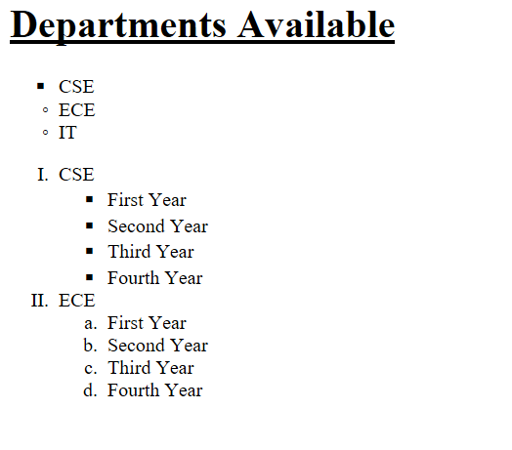

**Background in CSS**

<!DOCTYPE html>

<html>

<head>

<title>background image</title>

<style type="text/css">

p{

border-style: solid;

}

</style>

</head>

<body background="light_colored_fireworks.jpg">

<h1><center>Background Image</center></h1>

<p>

Welcome to GITAM, a centre for higher learning, offering quality higher education with consistently proven performance. Endowed in abundance by nature and enriched by competent faculty and state-of-the-art infrastructure, GITAM offers a delightful learning experience to all its stakeholders.

All our programmes are structured to meet industry requirements and changing aspirations of the students. The teaching-learning experience is unique in GITAM with emphasis on industry interaction, soft skills and practical exposure, in addition to face-to-face classroom interaction aided by the latest information and communication technologies.

In today’s competitive world, acquisition of multiple skills is imperative to succeed in one’s career. In the light of this, emphasis is also laid on enhancing the skill-set of the students to improve their employability. In addition to the regular chosen programmes, students can also opt for suitable additional programme(s) through GITAM Centre for Distance Learning.

GITAM always endeavors to make your learning experience not only pleasant but also highly rewarding and holistic for a bright future.

I feel honoured to extend to you a cordial welcome to this coveted centre of higher learning.

</p>

</body>

</html>

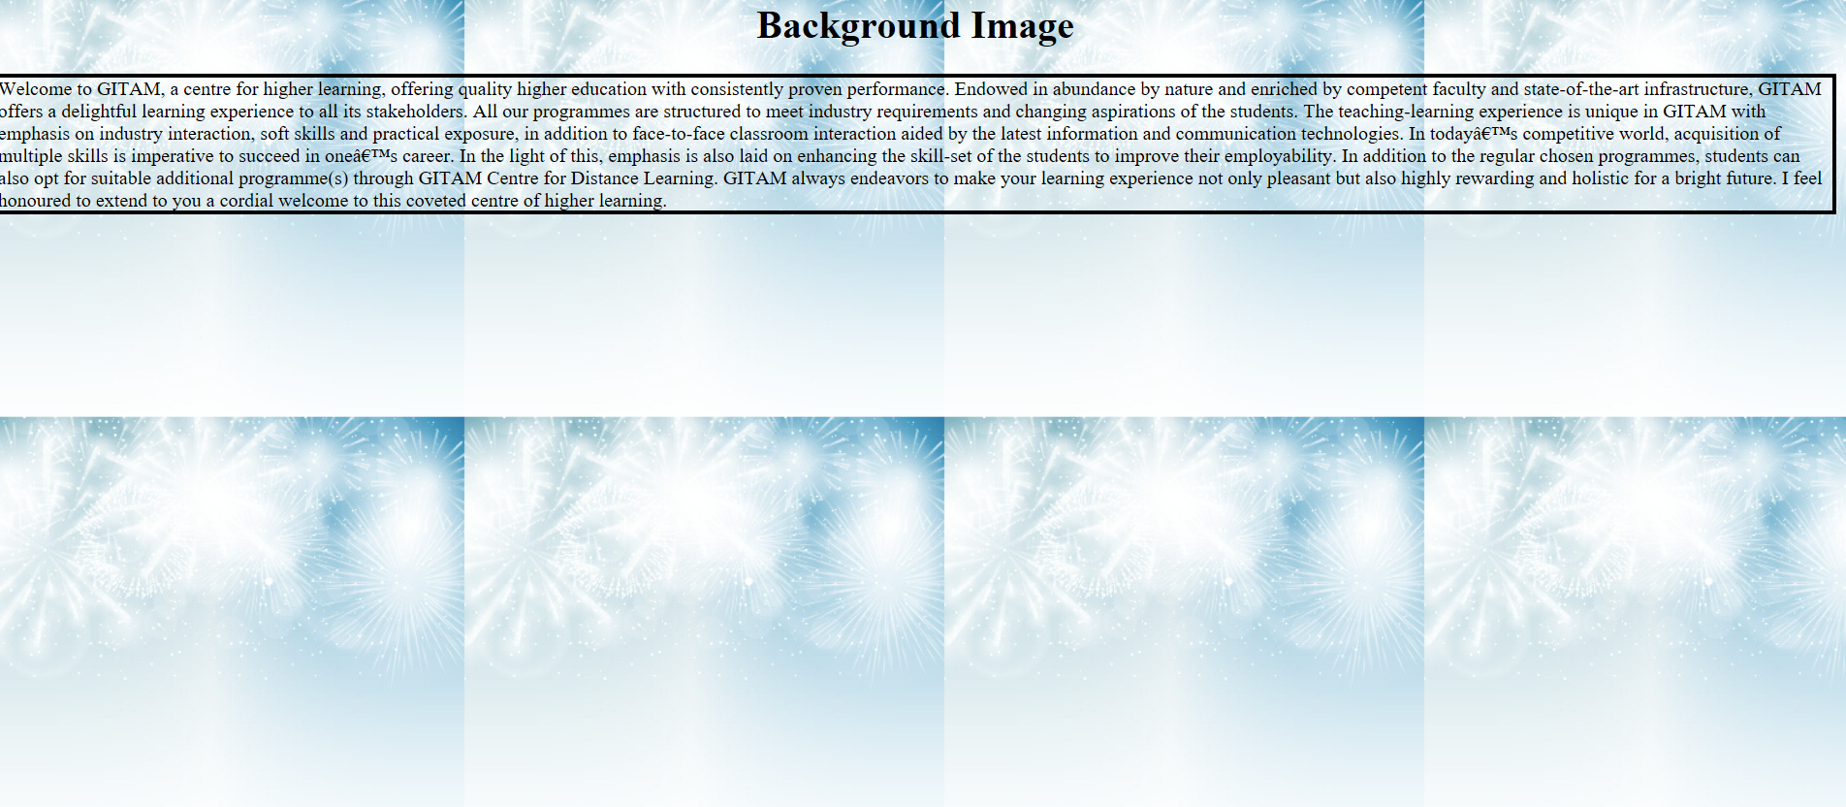

**Home Page using CSS**

<!DOCTYPE html>

<html>

<head>

<title>Style page</title>

<style type="text/css">

h1{

color: red;

size: 18;

text-decoration: underline;

text-align: center;

}

img{

float: left;

}

table{

border: 1;

border-top-left-radius: 5;

border-collapse: collapse;

border-left: solid;

border-right: solid;

float: right;

border-top: dotted;

border-bottom: dotted;

}

.caption1{

color: blue;

text-decoration:underline;

}

.heading1{

color: red;

}

</style>

</head>

<body>

<h1>GITAM..DEEMED TO BE UNIVERSITY</h1>

<hr>

<img src="logo-gitam-final.jpg">

<p >Gandhi Institute of Technology and Management, popularly known as GITAM, was founded in 1980 by an inspired group of eminent intellectuals and industrialists of Andhra Pradesh led by Dr.M.V.V.S.Murthi, former Member of Parliament and popular philanthropist.</p>

<p>

Our Alumni Who are spread world wide in various sectors both in technical and management are tiers, part of prestigious organisations like the Union Public Services, IITs and IIMs, Stanford University, to name a few. They are CEOs of reputed firms in the US, UK, Australia and a host of other countries.

</p>

<p>

To achieve global standards and excellence in teaching, research and consultancy by creating an environment in which the faculty and students share a passion for creating, sharing and applying knowledge to continuously improve the quality of education.

</p>

<p>

The kindling light with its bright rays represents GITAM and its many faculties of study spreading throughout the entire universe. The light of knowledge is pure and can kindle million more lights, thus spreading the effulgence beyond horizons, dispelling the darkness of ignorance in the entire globe.

</p>

<table border="5">

<tr>

<th class="caption1" colspan="3">Intake</th>

</tr>

<tr class="heading1">

<th>Year</th>

<th>CSE</th>

<th>ECE</th>

</tr>

<tr>

<th>2015-2016</th>

<td>1000</td>

<td>1000</td>

</tr>

<tr>

<th>2015-2016</th>

<td>1200</td>

<td>800</td>

</tr>

</table>

<p>

Welcome to GITAM, a centre for higher learning, offering quality higher education with consistently proven performance. Endowed in abundance by nature and enriched by competent faculty and state-of-the-art infrastructure, GITAM offers a delightful learning experience to all its stakeholders.

All our programmes are structured to meet industry requirements and changing aspirations of the students. The teaching-learning experience is unique in GITAM with emphasis on industry interaction, soft skills and practical exposure, in addition to face-to-face classroom interaction aided by the latest information and communication technologies.

</p>

<p>

In today’s competitive world, acquisition of multiple skills is imperative to succeed in one’s career. In the light of this, emphasis is also laid on enhancing the skill-set of the students to improve their employability. In addition to the regular chosen programmes, students can also opt for suitable additional programme(s) through GITAM Centre for Distance Learning.

GITAM always endeavors to make your learning experience not only pleasant but also highly rewarding and holistic for a bright future.

I feel honoured to extend to you a cordial welcome to this coveted centre of higher learning.

</p>

</body>

</html>

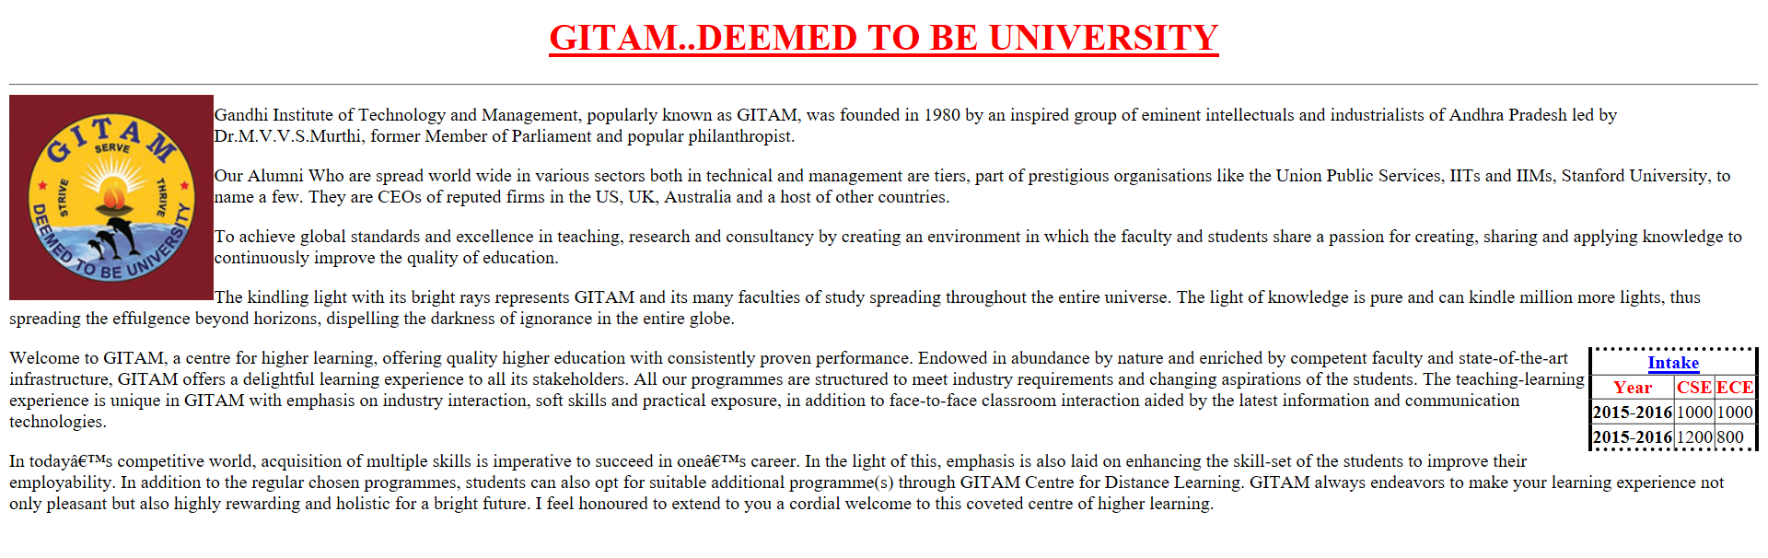

<**Span> and <Div> Tags**

<!DOCTYPE html>

<html>

<head>

<title>span and div tag</title>

<style type="text/css">

.span1{

color: red;

}

.div1{

border-style: solid;

text-indent: 10px;

}

p{

color: green;

}

</style>

</head>

<body>

<p>

Welcome to GITAM, a centre for higher learning, offering quality higher education with consistently proven performance. Endowed in abundance by nature and enriched by competent faculty and state-of-the-art infrastructure, GITAM offers a delightful learning experience to all its stakeholders.

All our programmes are structured to meet industry requirements and changing aspirations of the students. The teaching-learning experience is unique in GITAM with emphasis on industry interaction, soft skills and practical exposure, in addition to face-to-face classroom interaction aided by the latest information and communication technologies.<span class="span1">In today’s competitive world, </span>

</p>

<div class="div1">

<h1>This is div tag</h1>

<p>

All our programmes are structured to meet industry requirements and changing aspirations of the students. The teaching-learning experience is unique in GITAM with emphasis on industry interaction, soft skills and practical exposure, in addition to face-to-face classroom interaction aided by the latest information and communication technologies.

</p>

</body>

</html>

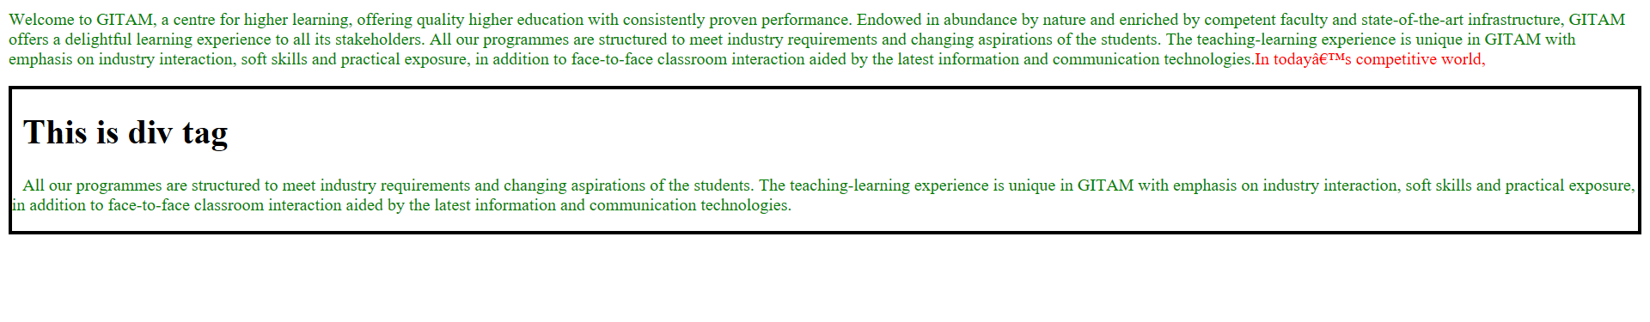

**Text Decoration using CSS styles**

<!DOCTYPE html>

<html>

<head>

<title>Text Decoration Properties</title>

<style type="text/css">

p{

text-decoration: underline;

text-decoration-color: blue;

color: green;

text-indent: 5;

text-align: left;

}

img{

float: left;

height: 50;

width: 100;

}

</style>

</head>

<body>

<p>

GITAM Institute of Technology (GIT) was established in the year 1980. Over the years the Institute has made its mark in engineering education across the nation. The programs offered by GIT have been accredited by National Board of Accreditation (NBA) three times and it became the first Institute of Andhra Pradesh to be conferred Autonomous status by the UGC in 2003. It became a constituent Institute of GITAM Deemed-to-be University in 2007 and was selected by MHRD in 2011 for TEQIP. The Institute has also been accredited with A grade by TCS.

</p>

<img src="logo-gitam-final.jpg"/>

</body>

</html>

